Ch. 11 Notes: Chemical Bonding
Ch. 11.1-11.3
Bond-a force that holds groups of two or more atoms together and makes them function as a unit

Bond energy- energy required to break a bond
Ex) Strong bond = high bond energy
Weak bond = low bond energy

Ionic vs. Covalent Bonds
Ionic
-Ionic bonds are formed between ions
-Ionic substances are composed of atoms that lose electrons easily and atoms that gain electrons easily
-Ionic bonds occur between a metal and nonmetal
-Ionic bonds are formed by electron transfer

Covalent
-Covalent bonds are formed between the negatively charged electrons of one atom, and the positively charged nucleus of another atom
-Covalent bonds occur between two nonmetals
-Covalent bonds are formed by electron sharing

Electronegativity-the ability of an atom in a molecule to attract shared electrons to itself
Pg. 320 in your book has a picture of the periodic table with electronegativity values for each element.
Electronegativity tends to increase from L to R across a period. This is because elements on the right side of the periodic table have more valence electrons and are therefore more likely to attract electrons in order to fill their outer shell.
Electronegativity tends to decrease from T to B down a group. This is because the elements towards the bottom of the periodic table have more energy orbitals. This causes the charge of the positive nucleus to decrease in strength, and therefore in its ability to attract electrons.

3 Stories of Atomic Relationships (Bonds)
1. Na and Cl
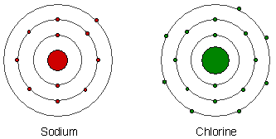
A. Sodium is a metal and chlorine is a nonmetal.
B. Chlorine is much more electronegative that sodium.
C. Chlorine is so electronegative that it steals sodium’s single valence electron, thereby creating two ions. Chlorine is now a -1 ion and sodium is now a +1 ion. The opposing charges of these two ions draw the two ions together.
D. This is known as an ionic bond.

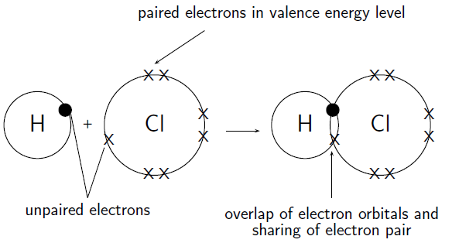
2. H and Cl

A. Hydrogen is a nonmetal and chlorine is a nonmetal.
B. Chlorine is slightly more electronegative that hydrogen.
C. Chlorine does not have enough electronegativity to steal hydrogen’s electron, so instead the two atoms share their unpaired electrons, giving both atoms stability. This is called a covalent bond.
D. Because chlorine is more electronegative, the shared pair of electrons will spend more time orbiting chlorine’s nucleus then they do orbiting hydrogen’s nucleus. This creates a dipole moment.
Dipole moment-occurs in a polar molecule when there is a slight concentration of positive charge at one end of the molecule and a slight concentration of negative charge at the other end.
Any molecule with a dipole moment is said to be a polar molecule. A polar molecule is bonded by polar covalent bonds. This is a special type of covalent bond.
Polar covalent bonds-UNEQUAL sharing of electrons

3. H and H
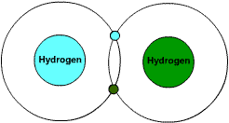

A. Both hydrogen atoms are nonmetals.
B. Both hydrogen atoms have the same electronegativity.
C. The two hydrogen atoms share the pair of electrons equally.
D. This results in a nonpolar covalent bond.
Nonpolar covalent bond-EQUAL sharing of electrons
There are no dipole moments in a nonpolar covalently bonded molecule.

Determining Types of Bonds Mathematically
Pg. 320 in your book has a picture of the periodic table with electronegativity values for each element.
Electronegativity Difference | Bond Type
0 | Nonpolar Covalent
0.1-1.7 | Polar Covalent*
1.9 + | Ionic
* Depending on the molecules doing the bonding, polar covalent bonds will have varying degrees of polarity. Ex) HCl (0.9) is more polar than HS (0.4).

Water
-Any two atom molecule with a polar covalent bond has a dipole moment.
-Only SOME polyatomic molecules have dipole moments. Water is an example of this.
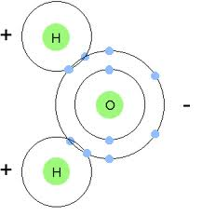

A. Oxygen is more electronegative than both hydrogen atoms, therefore, the shared electrons spend more time orbiting the oxygen nucleus than they spend orbiting hydrogen’s nucleus. This creates a dipole moment.
B. The hydrogen end of the molecule has a slightly positive concentration and the oxygen end of the molecule has a slightly negative concentration.

-The polarity of water molecules defines life as we know it!
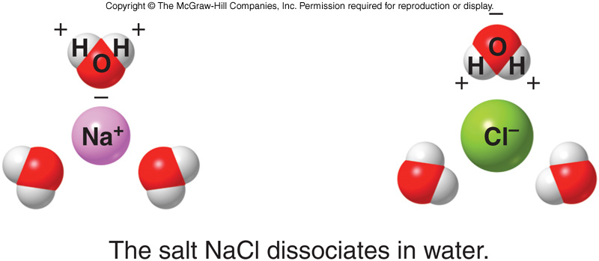
1. Water can surround both positive and negative particles (universal solvent)

2. Water is attracted to itself, so it takes a lot of energy to turn liquid water into a vapor
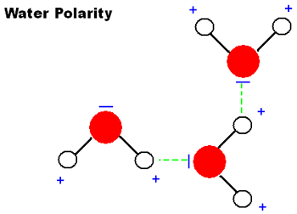

3. Water is attracted to other particles (plants take advantage of this)
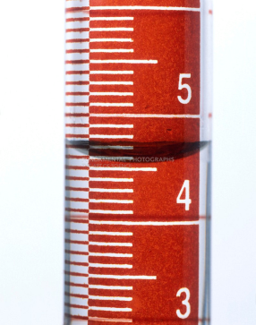

Ch. 11.6-11.7
Lewis Structure-representation of a molecule that shows how the valence electrons are arranged among the atoms in the molecule
Lewis structures are based on the idea that the most important requirement for the formation of a stable compound is that the atoms achieve full outer orbitals. So, when drawing Lewis structures, we only include valence electrons.

1. 2 chlorine atoms, each with 7 valence electrons
2. The two valence electrons that are by themselves are called the bonding pair of electrons
3. The three sets of valence electrons that are not involved in bonding are called lone pairs or unshared pairs
4. The bonding pair of electrons is then represented by a single line

Steps for Writing Lewis Structures
Step 1: Obtain the sum of the valence electrons for all atoms in the molecule.
Ex) H₂O = 2(1) + 6 = 8 total valence electrons
Step 2: Arrange the atoms so that the atom with most available bonding sites is in the center of the molecule. Use one pair of electrons to form a bond between each pair of bound atoms. Represent this pair of bonded electrons with a line.
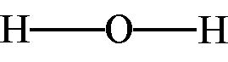
Ex)
Step 3: Arrange the remaining electrons to satisfy the duet rule for hydrogen and the octet rule for every other element.
Ex)

Lewis Structures of Molecules with Multiple Bonds
Draw a Lewis structure for CO₂
Step 1: CO₂ = 4 + 2(6) = 16 total valence electrons

Step 2: O—C—O
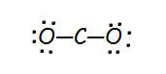
Step 3:

Is this correct? Why or why not?

How can we correct this drawing?
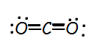

This is called a double bond. It is shorter in length than a single bond, and it is also stronger than a single bond.
Can we draw CO₂ another way that satisfies the octet rule?

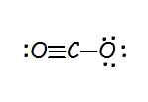

This structure contains a triple bond. A triple bond is even shorter in length and even stronger than a double bond.
When more than one correct Lewis structure can be drawn for a molecule, this is called resonance.

Drawing Lewis Structures for Polyatomic Ions
When drawing Lewis structures for polyatomic ions, follow the same general rules with one exception.
Draw a Lewis structure for CN⁻.
Step 1: CN⁻ = 4 + 5 + 1 = 10 total valence electrons
The -1 charge on the ion adds an additional electron.

Homework: Pg. 335
Self-Check (a-g) of first set

